Supplementary File -Jatems 214

Article Title: Phosphorus-based Carrying Capacity of Aquaculture Sites in Lake Victoria, Kenya
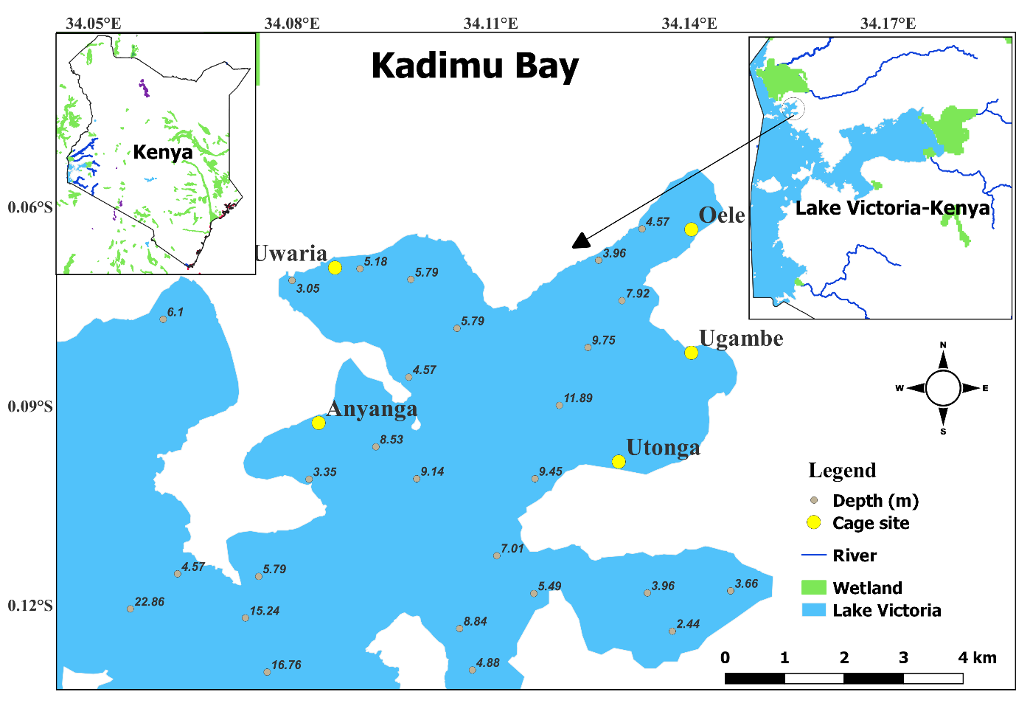
Figure 1: Map of Lake Victoria showing sampling sites: Anyanga, Uwaria, Oele, ugambe and, Utonga in the Kadimu Bay of Winam Gulf, Lake Victoria, Kenya. (Modified from KMFRI).
Table 1: Published estimates of the mean annual water balance parameters of Lake Victoria, and their reference sources. Adopted from Xungang and Nicholson (1998)
Period | Rainfall Over lake (mm/year) | Evaporation (mm/year) | Tributary inflow  (mm/year) | Reference source
 | 1420 | 1350 | 230 | Hurst (1952)
 | 1145 | 1130 | 237.5
1925-1959 | 1630 | 1523 | 260 | de Baulny and Baker (1970)
 | 1650 | 1500 | 250 | Hastenrath and Kutzbach(1983)
 | 1636 | 1459.5 | 238 | WMO (1974, 1981)
 | 1450 | 1370 | 260 | Spigel and Coulter (1996)
1956-1978 | 1810 | 1593 | 343 | Howell et al (1988)
1945-1984 | 1645 | 1470 | 0 | Flohn and Burkhardt (1985)
1950-1979 | 1660 | 1590 | 420 | Kite (1982)
1970-1974 | 1850 | 1595 | 343 | Piper et al (1986)
1956-1978 | 1476 | 1401 | 241 | Balek (1977)
Mean | 1579.27 | 1452.86 | 256.59

Table 2: Datasets for calculation of total phosphorus assimilation carrying capacity for cage sites in the Kadimu Bay, Lake Victoria, Kenya
Site | Surface area (m²) | Depth (m) | Volume (V) (m³) | Water Debit (Q) (m³/year) | Flushing rate (Ø =Q/V) (year⁻¹)
Anyanga | 617509 | 7.01 | 4328738.09 | 78059569.28 | 18.03
Oele | 22458 | 4.27 | 95895.66 | 2839172.37 | 29.61
Ugambe | 9250 | 8.84 | 81770 | 1169549.09 | 14.30
Utonga | 29122 | 10.67 | 310731.74 | 3681568.61 | 11.85
Uwaria | 137022 | 4.7 | 644003.4 | 173321207.61 | 26.89

Table 3: Total Phosphorus (TP) assimilation carrying capacity, fish production carrying capacity and hydrological parameters of cage sites within Kadimu Bay, Lake Victoria, Kenya
Site | TPmax (mg/m³) | ΔP(mg m-³) | Z(m) | Ø(year¹) | R | R_{Fish} | Lfish (g/m²/year)
Anyanga | 86.56 | 13.44 | 7.01 | 18.03 | 0.24 | 0.62 | 4.47
Oele | 96.61 | 3.39 | 4.27 | 29.61 | 0.19 | 0.595 | 1.058
Ugambe | 97.38 | 2.62 | 8.84 | 14.3 | 0.26 | 0.63 | 0.895
Utonga | 82.93 | 17.07 | 10.67 | 11.85 | 0.28 | 0.64 | 5.995
Uwaria | 55.16 | 44.84 | 4.7 | 26.87 | 0.2 | 0.6 | 14.167
Kadimu Bay | 83.73 | 16.27 | 7.098 | 20.132 | 0.234 | 0.617 | 6.07
All notations are as explained in the text

Table 4: TP carrying capacity, TP release by current fish production, Maximum potential fish production and current fish production by cage site in the Kadimu Bay, Lake Victoria, Kenya.
Site | TP carrying capacity (kg/year) | TP released by current fish production (kg/year) | Maximum potential fish production (ton/year) | Current fish production (ton/year)
Anyanga | 2,760.270 | 170,324 | 102.420 | 6,320
Oele | 23.761 | 113,190 | 0.882 | 4,200
Ugambe | 8.279 | 32,340 | 0.307 | 1,200
Utonga | 174.586 | 6,468 | 6.478 | 240
Uwaria | 1,941.191 | 21,560 | 72.029 | 800
Kadimu Bay | 4,949.241 | 343,882 | 183.645 | 12,760

