Supplementary file-Jatems 213

Paper Title: Efficacy of Commonly Used Sterilants and Disinfectants Against Bacterial Contaminants in a Clinical Laboratory Setting in Kenya

Table 1: Frequency of bacterial isolates from different sites /equipment within hospital settings
Microbes
Microbes | Workbenches | Walls | Floor | Equipment | Total
E. coli | 11(17.19) | 44(66.67) | 2(100) | 12(19.05) | 68(34.50)
K. pneumonia | 4(6.25) | 17(25.76) | 0(0) | 16(25.40) | 37(18.50)
S. aureus | 11(17.19) | 0(0) | 0(0) | 0(0) | 11(6.50)
P. aeruginosa | 0(0) | 1(1.52) | 0(0) | 16(25.40) | 17(9.00)
P. mirabilis | 0(0) | 0(0) | 0(0) | 7(11.11) | 7(3.50)
S. typhi | 14(21.88) | 0(0) | 0(0) | 0(0) | 14(7.00
S. pneumonia | 2(3.13) | 0(0) | 0(0) | 0(0) | 2(2.00)
Coliforms | 22(34.38) | 4(6.06) | 0(0) | 12(19.05) | 36(19.00)
Total | 64(32.00) | 66(33.00) | 2(1.00) | 63(31.50) | 192(100)

Table 2: Sterilants and disinfectants effectiveness profile of the isolated microbe according to BSAC
 | E. coli | K. pneumoniae | S. aureus | P. aeruginosa | P. mirabilis | S. typhi | S. pneumoniae | Coliforms
 | S:R
Alcohol | 65:30:5 | 87.5:12.5:0 | N/A | 93:0:7 | 80:20:0 | 0:0:100 | N/A | 87:13:0
Iodophor (10µg) | 0:0:100 | N/A | N/A | N/A | 0:0:100 | N/A | N/A | N/A
Hypochlorite | 36:0:64 | 33:0:67 | N/A | 0:0:100 | 71:0:29 | 71:0:29 | N/A | 22:0:78
Hydrogen peroxide | N/A | N/A | N/A | 0:0:100 | N/A | N/A | N/A | N/A
Glutaraldehyde | N/A | N/A | N/A | N/A | N/A | N/A | 0:0:100 | N/A
N/A= Microbe not applied on an isolate, S= Effective, R=Resistant

Figure 1: Sterilants and Disinfectants Efficacy Profile using MTRH Method

Table 3: Agreement in (%) of the BSAC and MTRH’s methods for all tested microbes

 | Number of tests | BSAC (S) | MTRH (S) | Agreement (%) | BSAC (R) | MTRH (R) | Agreement (%)
Alcohol | 92 | 64 | 88 | 67.4 | 16 | 4 | 2.2
Iodophor (10µg) | 31 | 0 | 0 | 100 | 31 | 31 | 100
Hypochlorites | 101 | 37 | 73 | 32.7 | 64 | 28 | 3
Hydrogen peroxide | 3 | 0 | 2 | 0 | 3 | 1 | 33.3
Gluteraldehydes | 3 | 0 | 3 | 0 | 3 | 0 | 0

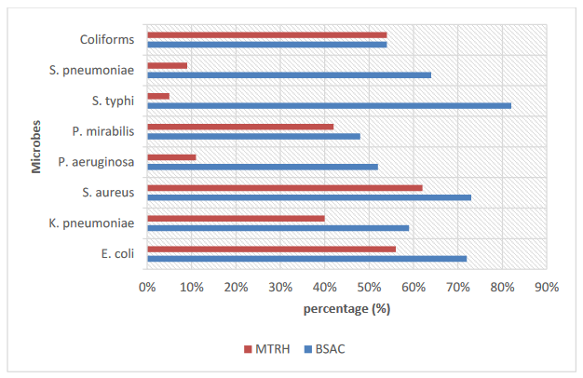

Figure 2: Comparison of resistance patterns of isolates using BSAC and MTRH methods

