Supplementary file -Jatem 211

Article Title: Mitigating Water Lily Invasion: Evaluating the Efficiency of a Novel Manual Machine in Aquaculture Ponds

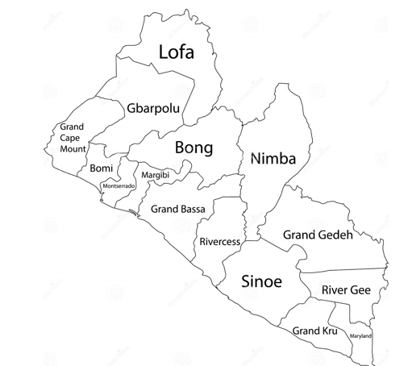
Figure 1: Map of Liberia showing all the counties (Bong and Nimba are located in the North Central part)

Table 1: Effect of the water lily to the fish farmers
What knowledge/experience you have on water lily? | Percent (%)
Basic knowledge | 46.6
No basic knowledge | 53.4
Have you made any effort to remove the water lily?
Yes | 93.3
No | 6.7
Most dominant species
Nymphaea sp | 42.6
Nelumbo nucifera | 35.7
Salvinia auriculata | 25.3
Mode of removal from the pond
Manually after harvesting we uproot it | 66.7
Manually by cutting with cutlass and hoe | 26.7
Spraying with Chemical | 6.7
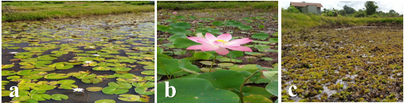
Figure 2: The different water lily species identified during the survey of the 2 counties; a- Nymphaea sp, b- Nelumbo nucifera, and c-Salvinia auriculata.

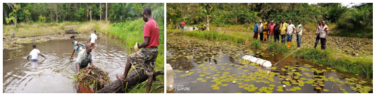Figure 3. Both types of weeding exercises are depicted. On the left if the manual is the manual exercise while on the right, is the use of the fabricated prototype

Table 2: The efficiency of the novel method compared to the conventional method of water lily removal
Community | Method | Pond size | Day (s) | Labour Cost/USD
Neingbin | Conventional | 1300m² | 2 | 32.00
Neingbin | Prototype | 1300m² | 1 | 16
Tudin | Conventional | 1500m² | 2 | 32.00
Tudin | Prototype | 1500m² | 1 | 16.00
Zowenta | Conventional | 1800 m² | 2.5 | 40.00
 | Prototype | 1800 m² | 1 | 16

