Supplementary file

Article Title: Some Aspects of Fish Biology and Ecology of River Perkerra in Lake Baringo Basin, Kenya

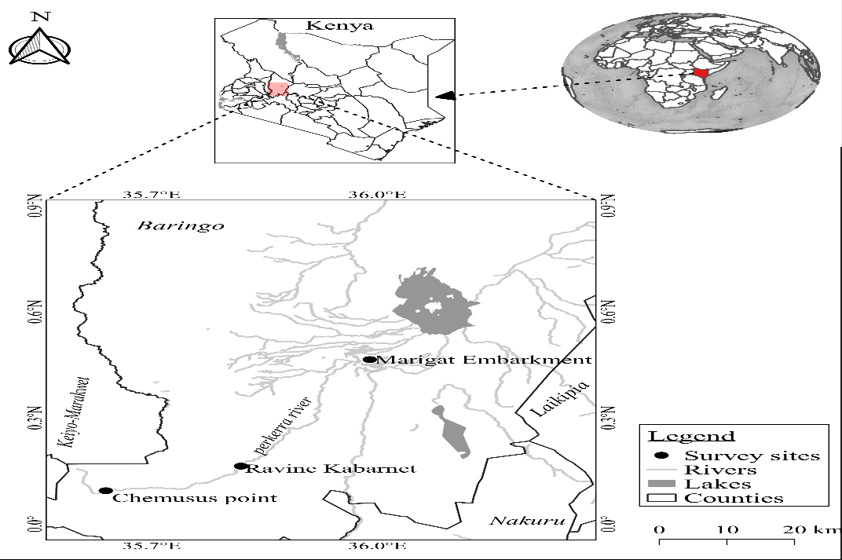
Figure 1: Map showing the location of the study area along River Perkerra

(a)
(b)

Figure 2. Food type and occurrence in percentage for (a) L. altenialis and (b) L. cylidricus in River Perkerra during the study period

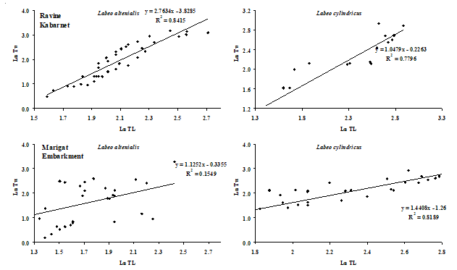

Figure 3: Length-weight relationships of fish species sampled from River Perkerra

Table 1: Description sampling sites
Sampling sites | Latitude | Longitude | Mean depth (m) | Mean width (m)
Chemusus point | E035⁰38'21.0'' | N00⁰05'39.5'' | 1.68 ± 0.34 | 18.5 ± 5.33
Ravine Kabarnet | E035⁰49'08.1'' | N00⁰09'49.5'' | 1.22 ± 0.55 | 4.5 ± 0.83
Marigat Embarkment | E035⁰59'24.4'' | N00⁰27'54.3'' | 1.28 ± 0.55 | 4.1 ± 0.76

Table 2: Mean value (±SE) of physicochemical parameters in River Perkerra at the three sampling stations during the study period.
Sampling stations
Parameters
Marigat Embankment
Ravine Kabarnet
Chemusus point
F
P - value

Temperature (ºC) | 15.2 ± 0.33ª | 16.3 ± 0.12^{b} | 16.8 ± 0.26^{b} | 20.91 | < 0.001
DO (mg/L) | 3.44 ± 0.21^{d} | 2.44 ± 0.08^{b} | 3.31 ± 0.30^{c} | 24.11 | < 0.001
TDS (mg/L) | 29.15 ± 1.39^{c} | 28.21± 1.28^{c} | 25.39 ±1.56^{b} | 40.46 | < 0.001
Salinity (ppt) | 0.14 ± 0.03^{c} | 0.13 ± 0.04^{b} | 0.12 ± 0.06ª | 7.86 | 0.003
pH | 6.95 ± 0.12^{c} | 7.39 ± 0.23^{d} | 6.45 ± 0.12^{b} | 20.05 | < 0.001
Secchi disk (cm) | 0.97 ± 0.25ª | 0.97 ± 0.33ª | 0.99 ± 0.16ª | 8.04 | 0.002
Phosphates (mg/L) | 1.93 ± 0.17^{b} | 1.75 ± 0.11ª | 2.99 ± 0.16^{d} | 14.52 | < 0.001
Nitrates (mg/L) | 3.80 ± 0.12^{b} | 4.25 ± 0.18^{c} | 3.49 ± 0.14ª | 3.8 | 0.013
Table 3: Description of the biological data of the fish species captured at three stations along River Perkerra. Sample size (n), (mean ± SE [Range]) fork length (FL) and (mean ± SE) weight
Sampling sites | Fish species | n | FL (cm) | Mean weight (g)
Chemusus point | No fish | -
Ravine Kabarnet | L. altenialis | 72 | 12.44 ± 3.95 [4.3-22.7] | 20.16 ± 6.17
 | L. cylindricus | 5 | 16.72 ± 4.43 [3.7-25.7] | 42.16 ± 8.10
Marigat Embarkment | L. altenialis | 42 | 10.42 ± 2.41 [3.1-25.3] | 52.11 ± 12.13
Marigat Embarkment | L. cylindricus | 211 | 18.32 ± 4.41 [5.7-28.3] | 52.62 ± 11.37
*Mean values with different superscripts across the same rows show significant difference (p ˃ 0.05).

Table 4: Stomach fullness index in Perkerra River during the sampling period (n=330)
 | Species | ¼ Full | ½ Full | ¾ Full | Empty | Full |  | Total
Ravine Kabarnet | L. altenialis | 9.7 | 11.0 | 62.5 | 9.7 | 2.8 |  | 100.0
Ravine Kabarnet | L. cylindricus | 0.0 | 20.0 | 60.0 | 20.0 | 0.0 |  | 100.0
Marigat Embarkment | L. altenialis | 9.5 | 26.2 | 38.1 | 9.5 | 16.7 |  | 100.0
Marigat Embarkment | L. cylindricus | 12.3 | 22.3 | 51.7 | 8.5 | 4.7 |  | 100.0

Table 5: Sex ratios of fish sampled along different locations of River Perkerra
Sampling sites | Fish species | Sex ratio  (male: female)
Chemusus | - | -
Ravine Kabarnet | Labeo altenialis | 5:7
 | Labeo cylindricus | 3:5
Marigat Embarkment | Labeo altenialis | 4:32
 | Labeo cylindricus | 14:23

Table 6: Percent maturity stages of fish species at Perkerra river (n=330) during the sampling period

Species | I | II | III | IV | V | Spent
L. altianalis | 26.3 | 17.5 | 26.3 | 18.1 | 7.0 | 4.7
L. cylindricus | 14.5 | 13.2 | 22.6 | 30.2 | 9.4 | 10.1
Total | 40.8 | 30.8 | 49.0 | 48.3 | 16.5 | 14.7

