Supplementary file -Jatems 224

Article Title: Economic Viability of Agricultural Carbon Sources on Asian Rice (Oryza sativa Lejeunia 1753.) and Nile Tilapia (Oreochromis niloticus) Production in a Flocponic System

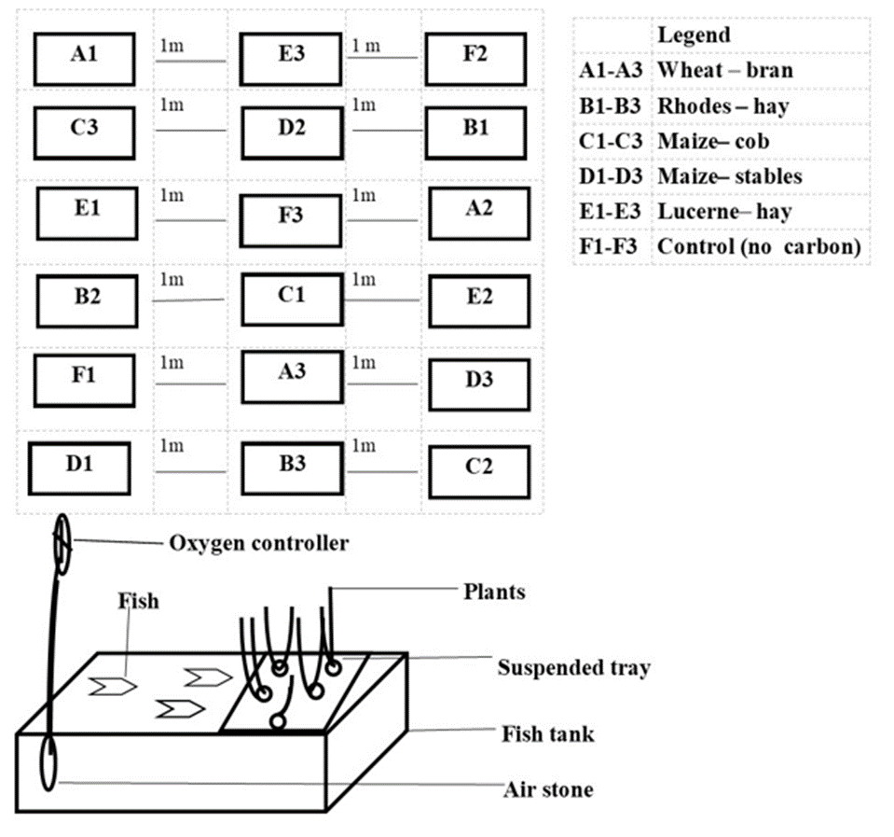
Plate 1: Experimental treatments (wheat-hay, rhodes-hay, maize-cob, maize-stables, and lucerne-hay) and control layout design in a flocponic system
Table 1: Mean± SE levels of simple and complex sugars of agricultural by-products (wheat-bran, rhodes-hay, maize-cob, maize-stables, and lucerne-hay)
Carbohydrate  (Mg/100ml) | Wheat-bran | Rhodes-hay | Maize-cob | Maize-stables | Lucerne-hay
Starch | 51.78±0.62ª | 70.26±0.70^{b} | 74.18±0.47^{c} | 20.86±0.74^{d} | 21.31±0.42^{d}
Cellulose | 1466.60±16.30ª | 1586.70±27.30^{b} | 1596.90±20.80^{b} | 1720.00±16.90^{c} | 765.00±20.20^{d}
Fructose | 46.24±0.55ª | 51.33±5.11ª | 32.61±1.76^{b} | 21.99±0.74^{b} | 68.77±1.80^{c}
Glucose | 16.97±0.536ª | 10.94±0.357^{b} | 9.23±0.279^{b} | 10.39±0.413^{b} | 22.16±1.31^{c}
Note: Values with different superscripts (^{a, b, c, d, e}) within the same row are significantly (p<0.05) different.
Table 2. Yields of Nile tilapia and rice at different agricultural carbon sources wheat-bran, Rhodes-hay, maize-cob, maize-stables and lucerne-hay) and control in flocponic systems
Parameters |  |  | CARBON SOURCES
 | Wheat-bran | Rhodes-hay | Maize-cob | Maize-stables | Lucerne-hay | control | F-value | p-value
Fish yield (Kgm⁻³) | 2.11±0.01ª | 1.83±0.01^{b} | 1.62±0.02^{c} | 1.35±0.01^{d} | 2.53±0.02e | 1.36±0.01^{d} | 1280.13 | 0.0001
Rice grain Yield (Kgm⁻³) | 3.41±0.12ª | 3.31±0.14ª | 2.56±0.13^{b} | 2.36±0.07^{c} | 5.70±0.25^{d} | 2.09±0.04e | 105.98 | 0.0001
Rice straw yield (Kgm⁻³) | 5.58±0.14ª | 4.84±0.08ª | 3.18±0.01^{b} | 2.41±0.02^{c} | 6.93±0.03^{d} | 2.09±0.04e | 798.42 | 0.0001
Total yield (Kgm⁻³) | 11.02 | 9.98 | 7.36 | 6.12 | 15.16 | 5.54

Table 3: Cost and returns (Kshs) and in flocponic systems at different agricultural carbon sources (wheat-bran, Rhodes-hay, maize-cob, maize-stables, and lucerne-hay) and control
Parameter (Kshs) | CARBON SOURCES
Parameter (Kshs) | Wheat-bran | Rhodes-hay | Maize-cob | Maize-stables | Lucerne-hay | Control
Revenue from fish yield (Kshs) | 845.21 | 731.95 | 645.84 | 539.14 | 1013.69 | 543.82
Revenue from rice seeds yield | 681.78 | 661.56 | 512.22 | 471.24 | 1138.92 | 417.42
revenue from rice straw (stables) yield | 836.70 | 725.70 | 477.12 | 360.99 | 1039.80 | 312.96
Gross revenue (Total revenue) | 2363.69 | 2119.21 | 1635.18 | 1371.37 | 3192.41 | 1274.20
variable costs
fish feeds | 120.85 | 120.00 | 120.00 | 119.00 | 121.2 | 120.00
Carbon source | 50.00 | 20.00 | 15.00 | 10.00 | 20.00 | 0.00
water | 130.00 | 130.00 | 135.00 | 140.00 | 130.00 | 150.00
Electricity | 350.00 | 350.00 | 350.00 | 350.00 | 350.00 | 350.00
miscellaneous | 200.00 | 200.00 | 200.00 | 200.00 | 200.00 | 200.00
Sub-total variable costs | 850.85 | 820.00 | 820.00 | 819.00 | 821.20 | 820.00
Interest on operating cost | 153.153 | 147.60 | 147.60 | 147.42 | 147.816 | 147.60
Total variable cost (TVC) | 1004.003 | 967.60 | 967.60 | 966.42 | 969.016 | 967.60
Fixed Costs
Fish holding unit | 450.00 | 450.00 | 450.00 | 450.00 | 450.00 | 450.00
air pump | 200.00 | 200.00 | 200.00 | 200.00 | 200.00 | 200.00
amortization | 100.00 | 100.00 | 100.00 | 100.00 | 100.00 | 100.00
sub-total fixed cost | 750.00 | 750.00 | 750.00 | 750.00 | 750.00 | 750.00
Interest on the fixed cost | 135.00 | 135.00 | 135.00 | 135.00 | 135.00 | 135.00
Total fixed cost | 885.00 | 885.00 | 885.00 | 885.00 | 885.00 | 885.00
Total cost (TC) | 1889.00 | 1852.60 | 1852.60 | 1851.42 | 1854.02 | 1852.60
Net return TVC (Gross margin) | 1359.69 | 1151.61 | 667.58 | 404.95 | 2223.39 | 306.60
Net return TC (Net income) | 474.69 | 266.61 | -217.42 | -480.05 | 1338.39 | -578.40
Cost Per Unit (CPU) | 212.95 | 212.44 | 222.28 | 224.42 | 210.57 | 230.29
Break-even price (BEP) | 170.18 | 185.71 | 251.83 | 302.98 | 122.29 | 334.83
margin (CPU and BEP) | 122.50 | 115.44 | 90.75 | 66.27 | 146.65 | 55.41
Note: 1 USD =120 average exchange rate during the 2023 production cycle.

Table 4: Profitability ratio (Kshs) in flocponic system at different treatments (wheat-bran, Rhodes-hay, maize-cob, maize-stables, and lucerne-hay carbon sources) and control
Parameter | CARBON SOURCES (TREATMENTS)
Profitability ratios | Wheat-bran | Rhodes-hay | Maize-cob | Maize-stables | Lucerne-hay | Control
BCR (Benefit-cost ratio) | 1.25 | 1.14 | 0.88 | 0.74 | 1.72 | 0.69
ESR (Expense Structure ratio) | 0.88 | 0.92 | 0.92 | 0.92 | 0.91 | 0.92
GRR (Gross revenue ratio) | 79.92 | 87.42 | 113.29 | 135.01 | 58.08 | 145.39
RoI (Return on investment) % | 25.13 | 14.39 | -11.74 | -25.93 | 72.19 | -31.22
Note: 1 USD =120 average exchange rate during the 2023 production cycle

