Supplementary file -Jatems 215

Article Title: Spatio-Temporal Variability in Water Quality and Zooplankton Assemblages within Chemususu Dam and Associated Rivers, Baringo County, Kenya

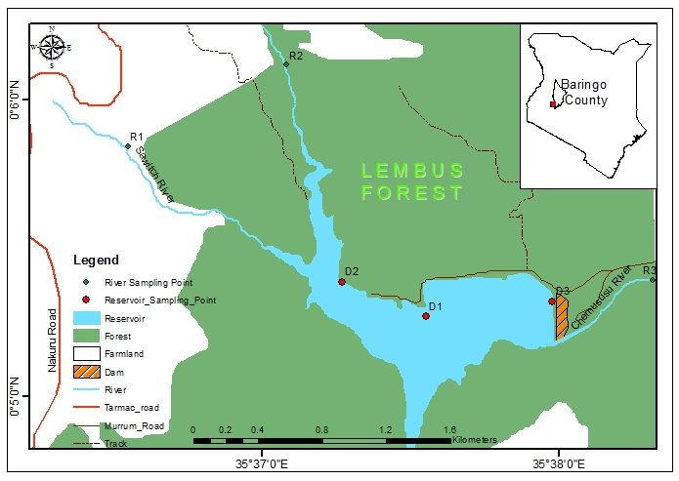
Barain River
Figure 1: Map of Chemususu Dam indicating the sampling points for the study R1-River Sawich, R2-River Barain, R3-River Chemususu, while D1, D2, and D3 are sampling sites within the dam (https://www.arcgis.com/home/webmap)

Table 1: Spatial variation of physicochemical parameters and nutrients of Chemususu dam and associated rivers during the dry season (Mean±SE)
Sites | Temp (⁰C) | DO (mg/L) | TDS (mg/L) | TSS (mg/L) | Sal. (ppt) | pH (Std_Units) | Condu. (μS/cm) | Turb (NTU) | PO₄ (mg/L) | NO₃ (mg/L) | Carbonates (mg/L) | Chlorides (mg/L)
D1 | 20.35±0.61a | 2.30±0.12a | 40.92±0.96a | 11.68±0.08a | 0.06±0.51a | 5.88±0.32a | 75.50±0.91a | 0.58±0.41a | 1.27±0.22a | 5.40±0.4a | 10.20±0.85a | 2.30±0.55a
D2 | 20.05±0.24a | 2.27±0.26a | 46.45±0.56a | 13.34±0.97a | 0.07±0.54a | 5.79±0.33a | 73.40±0.09a | 0.38±0.52a | 2.39±0.07a | 4.34±0.21b | 10.00±0.73a | 2.50±0.29a
D3 | 20.68±0.16a | 2.32±0.27a | 42.25±0.66a | 12.08±0.81a | 0.07±0.52a | 5.82±0.36a | 89.20±0.29a | 0.40±0.87a | 2.42±0.16a | 3.58±0.24b | 10.50±0.49a | 2.70±0.09a
RC | 16.83±0.23b | 3.00±0.38b | 68.00±0.06b | 12.80±0.75b | 0.08±0.44a | 6.31±0.42b | 92.00±0.31a | 0.31±0.93a | 2.57±0.77a | 3.50±0.23b | 10.60±0.27a | 2.60±0.32a
RS | 15.85±0.25b | 2.97±0.56b | 85.50±0.35b | 25.05±0.67b | 0.12±0.41b | 6.55±0.78b | 70.30±0.61a | 0.32±0.48a | 3.54±0.45a | 1.95±0.34c | 7.00±0.25b | 2.40±0.37a
RB | 16.85±0.36b | 2.85±0.44b | 86.83±0.04b | 25.45±0.51b | 0.13±0.21b | 6.73±0.83b | 76.00±0.33a | 0.40±0.44 | 3.60±0.26a | 2.68±0.64c | 6.60±0.34b | 2.30±0.38a
Mean | 18.44±0.61b | 2.62±0.94b | 61.66±8.72 | 19.23±3.1 | 0.09±0.01a | 6.18±0.17 | 79.4±3.65 | 0.33±0.08 | 2.63±0.35 | 3.58±0.5 | 9.15±0.75b | 2.47±0.07
F values | 7.23 | 1.35 | 2.32 | 1.96 | 2.36 | 3.87 | 1.65 | 3.24 | 2.56 | 3.81 | 3.26 | 1.25
P values | 0.030 | 0.011 | 0.015 | 0.020 | 0.016 | 0.010 | 0.108 | 0.620 | 0.150 | 0.020 | 0.030 | 0.112
Means along the column followed by same letters are not significantly different, Significant level p<0.05

Table 2: Spatial variation of physicochemical parameters and nutrients of Chemususu dam and associated rivers during the wet season (Mean ±SE)
Sites | Temp (⁰C) | DO (mg/L) | TDS (mg/L) | TSS (mg/L) | Sal. (ppt) | pH (Std_Units) | Condu. (μS/cm) | Turb (NTU) | PO₄ (mg/L) | NO₃ (mg/L) | Carbonates (mg/L) | Chlorides (mg/L)
D1 | 19.25±0.56a | 5.22±0.15a | 49.88±0.23a | 14.37±0.23a | 0.08±56a | 6.45±0.25a | 71.10±0.56a | 0.25±0.25a | 2.18±0.25a | 5.89±0.24a | 6.40±0.00a | 2.00±0.067a
D2 | 20.65±0.75a | 4.67±0.21a | 51.58±0.62a | 14.88±0.12a | 0.08±86a | 6.09±0.46a | 72.13±0.86a | 0.20±0.37a | 2.48±0.27a | 5.50±0.23a | 6.40±0.23a | 2.80±0.82a
D3 | 20.70±0.66a | 4.51±0.22a | 74.58±0.61b | 13.78±0.14a | 0.09±81a | 5.72±0.78a | 71.60±0.52a | 0.15±0.26a | 2.54±0.24a | 4.05±0.21a | 8.00±0.44a | 3.30±0.78a
RC | 15.18±0.33b | 3.88±0.33b | 76.92±0.25b | 22.48±0.12b | 0.09±14a | 5.83±0.42a | 72.60±0.26a | 0.18±0.21a | 2.04±0.36a | 4.10±0.62a | 8.00±0.24a | 3.20±0.74a
RS | 17.73±0.29b | 5.03±0.38b | 81.58±0.87b | 20.88±0.45b | 0.11±26b | 6.81±0.78a | 58.20±0.23b | 0.20±0.24a | 2.04±0.24a | 5.26±0.63a | 6.30±0.56a | 2.10±0.72a
RB | 16.30±0.42b | 5.71±0.42b | 92.17±0.45b | 17.05±0.56b | 0.10±25b | 6.12±0.25a | 56.30±0.23b | 0.00±0.23a | 3.50±0.21b | 5.20±0.63a | 6.40±0.52a | 3.00±0.78a
Mean | 18.30±0.88 | 4.84±0.26 | 71.12±0.91 | 17.24±1.49 | 0.09±0.00 | 6.17±0.16 | 66.99±3.1 | 0.16±0.04 | 2.46±0.23 | 5±0.31 | 6.92±0.34 | 2.73±0.23
F values | 5.63 | 3.21 | 5.67 | 7.12 | 6.23 | 2.33 | 11.44 | 2.58 | 12.66 | 1.83 | 2.56 | 3.45
P values | 0.04 | 0.080 | 0.040 | 0.030 | 0.020. | 0.250 | 0.034 | 0.290 | 0.080 | 0.240 | 0.640 | 0.250
Means along the column followed by same letters are not significantly different, significant level p<0.05

Table 3: Zooplankton composition and distribution at Chemususu Dam
Taxa | Sites | D1 |  | D2 |  | D3 |  | RC |  | RS |  | RB
Taxa | Species/Season | Dry | Wet | Dry | Wet | Dry | Wet | Dry | Wet | Dry | Wet | Dry | Wet
Rotifera | Adineta sp | - | - | - | √ | - | √
Rotifera | Agnatha sp | - | - | - | √ | - | √
Rotifera | Castropus sp | - | - | - | - | - | √
Rotifera | Chromogaster sp | - | √ | - | - | - | -
Rotifera | Colotheca sp |  |  |  |  |  |  | - | - | - | √ | - | -
Rotifera | Colurella sp | - | - | √ | √ | √ | √
Rotifera | Conochillus sp | - | - | - | - | - | √
Rotifera | Dicranophorus sp | - | - | - | √ | - | -
Rotifera | Ephiphanes spp |  |  |  |  |  |  | - | √ | - | - | - | -
Rotifera | Estheria sp | - | √ | √ | - | - | √ | √ | √ | - | √ | - | √
Rotifera | Filinia sp | - | √ | - | - | - | - | - | √ | - | √ | - | -
Rotifera | Floscularia sp | - | - | - | √ | - | -
Rotifera | Gastropus sp | - | - | - | - | - | √
Rotifera | Kellicottia sp | - | √ | - | √ | - | -
Rotifera | Keratella sp | √ | - | √ | - | √ | - | - | √ | - | - | - | -
Rotifera | Lecane sp | - | √ | - | - | - | -
Rotifera | Malleate sp | - | - | - | √ | - | √
Rotifera | Mytilini sp | √ | √ | √ | - | √ | √ | - | √ | √ | √ | √ | √
Rotifera | Notholca sp | √ | - | √ | √ | - | -
Rotifera | Philodina sp | √ | √ | √ | - | - | √ | - | √ | - | √ | √ | -
Rotifera | Ploesoma sp | - | - | - | √ | √ | - | √ | - | - | - | - | -
Rotifera | Polyarthra sp. | √ | √ | - | - | - | - | - | √ | - | - | - | √
Rotifera | Rotaria sp | √ | √ | √ | - | √ | √ | - | √ | - | - | - | -
Rotifera | Synchaeta sp | - | √ | - | - | - | - | - | √ | - | √ | - | -
Rotifera | Testudinella sp. | - | √ | - | - | - | -
Rotifera | Trichocerca sp |  |  |  |  |  |  | - | - | - | √ | √ | -
Rotifera | Trichotria spp | - | - | - | √ | - | - | - | √ | - | - | - | -
Copepoda | Canthocamptus sp | √ | √ | - | - | - | -
Copepoda | Cyclops sp | - | - | - | - | - | √
Copepoda | Diamtomus sp | √ | √ | √ | √ | √ | √ | - | √ | - | √ | - | -
Copepoda | Eucyclops sp | - | - | √ | - | - | -
Copepoda | Limnocalanus sp | - | √ | - | - | - | -
Cladocerans | Acroperus sp |  |  |  |  |  |  | - | √ | - | - | - | -
Cladocerans | Rosimia sp |  |  |  |  |  |  | - | √ | - | √ | - | √
Cladocerans | Alonella sp | - | √ | - | - |  | -
Cladocerans | Bosmina sp | - | - | - | - | - | √ | - | √ | - | - | - | √
Cladocerans | Camptocercus sp | √ | √ | √ | √ | √ | - | √ | √ | √ | √ | √ | √
Cladocerans | Chydorus sp | - | - | - | √ | - | - | √ | √ | - | - | - | -
Cladocerans | Daphinia sp | √ | √ | √ | √ | √ | - | - | - | - | √ | - | √
Cladocerans | Diaphanosoma sp | √ | √ | √ | √ | √ | √ | - | √ | - | √ | - | -
Cladocerans | Eurycercus sp | - | √ | - | √ | - | -
Cladocerans | Macrothrix sp | - | - | - | √ | √ | √ | - | √ | - | - | - | -
Cladocerans | Simocephalus sp | √ | - | - | - | - | - | - | √ | - | - | - | -
Ostracodas | Cypridopsis sp | √ | √ | √ | √ | √ | √ | - | √ | - | √ | - | -
Ostracodas | Eubranchipus sp | - | - | √ | - | - | -
((√) = present; (−) = absent)

Table 4: Spatial and seasonal differences in the diversity indices of zooplankton of Chemususu dam
 | DRY SEASON |  |  |  |  |  |  |  | WET SEASON
 | D1 | D2 | D3 | RC | RS | RB |  |  |  | D1 | D2 | D3 | RC | RS | RB
Taxa_S | 4 | 4 | 4 | 2 | 2 | 2 |  |  |  | 4 | 4 | 4 | 4 | 4 | 3
Individuals | 31 | 37 | 35 | 22 | 20 | 11 |  |  |  | 257 | 196 | 179 | 140 | 154 | 85
Dominance_D | 0.27 | 0.33 | 0.35 | 0.63 | 0.49 | 0.45 |  |  |  | 0.31 | 0.34 | 0.32 | 0.30 | 0.38 | 0.40
Simpson_1-D | 0.73 | 0.67 | 0.65 | 0.37 | 0.51 | 0.55 |  |  |  | 0.69 | 0.66 | 0.68 | 0.70 | 0.62 | 0.60
Shannon_H | 1.25 | 1.15 | 1.14 | 0.51 | 0.65 | 0.64 |  |  |  | 1.27 | 1.14 | 1.19 | 1.26 | 1.08 | 0.96
Evenness_e^H/S | 0.87 | 0.79 | 0.78 | 0.84 | 0.96 | 0.95 |  |  |  | 0.89 | 0.78 | 0.82 | 0.88 | 0.74 | 0.87
Brillouin | 1.13 | 1.06 | 1.04 | 0.46 | 0.59 | 0.56 |  |  |  | 1.24 | 1.11 | 1.16 | 1.22 | 1.05 | 0.92
Menhinick | 0.72 | 0.66 | 0.68 | 0.43 | 0.45 | 0.60 |  |  |  | 0.25 | 0.29 | 0.30 | 0.34 | 0.32 | 0.33
Margalef | 0.87 | 0.83 | 0.84 | 0.32 | 0.33 | 0.42 |  |  |  | 0.54 | 0.57 | 0.58 | 0.61 | 0.60 | 0.45
Equitability_J | 0.90 | 0.83 | 0.82 | 0.74 | 0.93 | 0.93 |  |  |  | 0.92 | 0.82 | 0.86 | 0.91 | 0.78 | 0.88
Fisher_alpha | 1.22 | 1.14 | 1.16 | 0.53 | 0.55 | 0.72 |  |  |  | 0.67 | 0.71 | 0.73 | 0.77 | 0.75 | 0.61
Berger-Parker | 0.35 | 0.51 | 0.54 | 0.77 | 0.60 | 0.55 |  |  |  | 0.45 | 0.40 | 0.44 | 0.39 | 0.45 | 0.46
Key: D1= Dam site 1, D2= Dam site 2, D2= Dam site 3, RS = R. Sawich, RB= R. Baraini, and RC= R. Chemususu

Table 5: Pearson correlation analysis among zooplankton taxa with water quality variables and nutrients
ALL SEASONS
 | Tem (ºC) | DO (mg/L) | TDS (mg/L) | TSS (mg/L) | Sal. (ppt) | pH | Condu. (μS/cm) | Turb (NTU) | PO₄ (mg/L) | NO₃ (mg/L) | CO₃ (mg/L) | Cl (Mg/L)
Rotifer | 0.12 | 0.86 | 0.08 | -0.20 | 0.07 | 0.17 | -0.54 | -0.40 | -0.18 | 0.64 | -0.68 | 0.07
Copepoda | 0.02 | 0.24 | -0.08 | -0.04 | -0.17 | -0.18 | -0.14 | 0.00 | -0.51 | 0.32 | -0.13 | 0.13
Cladocera | 0.68 | 0.37 | -0.38 | -0.47 | -0.36 | -0.28 | 0.09 | -0.01 | -0.17 | 0.35 | -0.12 | 0.15
Ostracoda | 0.32 | 0.82 | -0.06 | -0.35 | -0.08 | 0.04 | -0.44 | -0.31 | -0.24 | 0.67 | -0.58 | 0.04
% Cladocera | -0.52 | 0.57 | 0.77 | 0.51 | 0.85 | 0.70 | -0.53 | -0.77 | 0.64 | -0.15 | -0.84 | -0.03
% Copepoda | 0.19 | -0.29 | -0.44 | -0.34 | -0.52 | -0.49 | 0.04 | 0.51 | -0.75 | 0.31 | 0.38 | 0.05
% Ostracodas | -0.08 | -0.76 | -0.13 | 0.35 | 0.00 | 0.06 | 0.75 | 0.33 | 0.32 | -0.72 | 0.58 | -0.19
% Rotifera | 0.34 | 0.81 | -0.06 | -0.58 | -0.23 | -0.22 | -0.63 | -0.26 | -0.32 | 0.82 | -0.44 | 0.23
DRY SEASON
Rotifera | -0.27 | 0.62 | 0.61 | 0.52 | 0.61 | 0.55 | 0.03 | -0.31 | 0.70 | -0.87 | -0.51 | 0.19
Copepoda | 0.71 | -0.88 | -0.84 | -0.88 | -0.76 | -0.81 | -0.24 | 0.75 | -0.87 | 0.91 | 0.54 | -0.16
Cladocera | 0.45 | -0.35 | -0.56 | -0.35 | -0.63 | -0.67 | 0.49 | 0.44 | -0.28 | 0.21 | 0.73 | 0.89
Ostracoda | 0.89 | -0.99 | -0.94 | -0.98 | -0.81 | -0.94 | -0.06 | 0.72 | -0.79 | 0.82 | 0.63 | 0.16
% Cladocera | -0.64 | 0.80 | 0.95 | 0.78 | 0.98 | 0.96 | -0.22 | -0.82 | 0.89 | -0.88 | -0.90 | -0.36
% Copepoda | 0.67 | -0.85 | -0.82 | -0.86 | -0.75 | -0.78 | -0.24 | 0.77 | -0.88 | 0.91 | 0.53 | -0.21
% Ostracodas | -0.62 | 0.73 | 0.51 | 0.75 | 0.32 | 0.44 | 0.52 | -0.46 | 0.55 | -0.61 | -0.04 | 0.52
% Rotifera | 0.86 | -0.98 | -0.94 | -0.98 | -0.82 | -0.92 | -0.07 | 0.75 | -0.83 | 0.85 | 0.63 | 0.10

WET SEASON
Rotifera | 0.33 | 0.12 | -0.67 | -0.32 | -0.22 | 0.55 | 0.13 | 0.63 | -0.39 | 0.64 | -0.59 | -0.62
Copepoda | -0.17 | -0.63 | -0.17 | 0.56 | -0.23 | -0.10 | 0.48 | 0.49 | -0.67 | -0.28 | 0.45 | -0.04
Cladocera | 0.98 | -0.05 | -0.74 | -0.86 | -0.77 | -0.26 | 0.67 | 0.44 | -0.13 | 0.14 | 0.12 | -0.06
Ostracoda | 0.76 | 0.16 | -0.81 | -0.68 | -0.57 | 0.28 | 0.44 | 0.67 | -0.36 | 0.52 | -0.26 | -0.58
% Cladocera | -0.50 | 0.52 | 0.36 | 0.16 | 0.60 | 0.50 | -0.76 | -0.39 | 0.39 | 0.39 | -0.68 | -0.21
% Copepoda | -0.32 | -0.73 | 0.02 | 0.70 | -0.09 | -0.20 | 0.41 | 0.35 | -0.60 | -0.45 | 0.55 | 0.14
% Ostracodas | 0.94 | -0.02 | -0.47 | -0.91 | -0.65 | -0.52 | 0.55 | 0.08 | 0.19 | -0.09 | 0.27 | 0.28
% Rotifera | 0.34 | 0.85 | -0.02 | -0.71 | 0.09 | 0.31 | -0.43 | -0.28 | 0.54 | 0.51 | -0.54 | -0.34
Legend: Temp. – Temperature, DO- Dissolved Oxygen, TSS-Total Suspended Solids, TDS – Total Dissolved Solids, Sal.-Salinity, Condu- Conductivity, Turb. – Turbidity, PO_{4 –} Phosphates, NO₃ – Nitrates, CO₃ – Carbonates, Cl – Chlorides.

Table 6: Ranked abundance of zooplankton taxa based results of SIMPER analysis
DRY SEASON |  |  |  |  |  |  |  | WET SEASON
Taxon | Av. Dissim | Contrib. % | Cumulative % | Mean DD | Mean RCD |  |  | Taxon | Av. dissim | Contrib. % | Cumulative % | Mean DW | Mean RCW
Copepoda | 13.78 | 39.01 | 39.01 | 7.67 | 0 |  |  | Ostracoda | 14.23 | 33.19 | 33.19 | 90 | 39
Ostracoda | 11.87 | 33.6 | 72.61 | 6.67 | 0 |  |  | Copepoda | 11.7 | 27.31 | 60.5 | 15.3 | 55
Cladocera | 6.702 | 18.98 | 91.58 | 16 | 17 |  |  | Cladocera | 8.857 | 20.66 | 81.16 | 42 | 11
Rotifera | 2.973 | 8.417 | 100 | 4 | 5 |  |  | Rotifera | 8.074 | 18.84 | 100 | 63.3 | 35
Taxon | Av. Dissim | Contrib. % | Cumulative % | Mean DD | Mean RSD |  |  | Taxon | Av. dissim | Contrib. % | Cumulative % | Mean DW | Mean RSW
Copepoda | 14.29 | 32.75 | 32.75 | 7.67 | 0 |  |  | Cladocera | 9.619 | 41.55 | 41.55 | 42 | 7
Ostracoda | 12.31 | 28.19 | 60.94 | 6.67 | 0 |  |  | Ostracoda | 7.052 | 30.46 | 72.02 | 90 | 63
Cladocera | 9.643 | 22.09 | 83.04 | 16 | 12 |  |  | Rotifera | 3.541 | 15.3 | 87.31 | 63.3 | 69
Rotifera | 7.404 | 16.96 | 100 | 4 | 8 |  |  | Copepoda | 2.937 | 12.69 | 100 | 15.3 | 15
Taxon | Av. Dissim | Contrib. % | Cumulative % | Mean DD | Mean RBD |  |  | Taxon | Av. dissim | Contrib. % | Cumulative % | Mean DW | Mean RBW
Cladocera | 21.62 | 37.75 | 37.75 | 16 | 6 |  |  | Ostracoda | 16.84 | 40.29 | 40.29 | 90 | 39
Copepoda | 17.18 | 30 | 67.76 | 7.67 | 0 |  |  | Cladocera | 10.87 | 26.01 | 66.3 | 42 | 10
Ostracoda | 14.76 | 25.78 | 93.54 | 6.67 | 0 |  |  | Rotifera | 9.248 | 22.12 | 88.42 | 63.3 | 36
Rotifera | 3.701 | 6.462 | 100 | 4 | 5 |  |  | Copepoda | 4.841 | 11.58 | 100 | 15.3 | 0
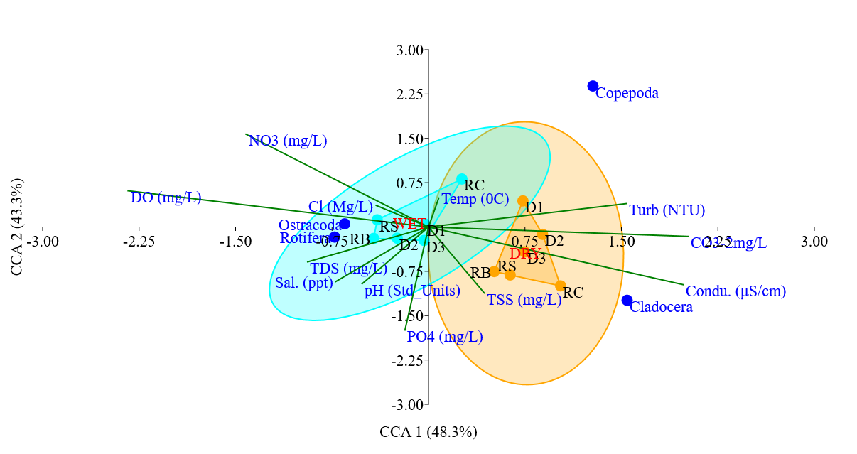
Figure 3: Canonical correspondence analysis Triplot indicating the interactive effect of seasons and quality of water quality on zooplankton taxa of Chemususu dam, Baringo County

