Supplementary file -Jatem 222

Article Title: Characterization of Essential Oils of Teclea nobilis and Zanthoxylum gilletii

Table 1: Chemical profile of EO of T. nobilis leaves
Plant species | Location | Major compounds
T. nobilis | Kenya | β- ocimene (10.15 %), γ- terpinene (6.11 %), α- pinene (3.95 %), neoallo-ocimene (3.68 %) and limonene (3.34 %), β- cadinene (4.98 %), 1,6- germacradien-5-ol (4.38 %), α-amorphine (3.96 %), τ-cadinol (3.56 %) and germacrene D (3.06 %) (Njogu et al., 2014)
T. nobilis | Saudi Arabia | Germacrene-D (19%), Ocimene isomers (22.3%), Guaiol (3.9%), Elemol (2.9%) and Bulnesol (2.5%) (Al-Rehaily, 2001)
T. nobilis | Uganda | Trans-ꞵ-ocimene (8.5%), δ-cadinene (7.3%), γ-elemene (2.4%), Germacrene-D (54.4%), α-Gurjunene (4.9%), α-cadinol (9.1%), τ-cadinol (2%), Nerolidol (1.9%), Methyl isoeugenol (1.7%) and palmitic acid (2.1%) (Ocheng et al., 2015)

Table 2: Chemical profile of essential oils of Z. gilletii's leaves
Plant Species | Location | Major Compounds
Z. gilletii | Kakamega, Kenya | γ-terpinene (10.62%), β-myrcene (5.16%), sabinene (4.89%), β-ocimene (3.12%), camphene (2.56%) trans-caryophyllene (9.82%), caryophyllene oxide (4.4%), α-cadinol (2.71%), 1, 1, 4, 8-tetramethyl-4, 7, 10- cycloundecatriene (2.62%), δ-cadinene (2.52%) and τ-cadinol (2.29%) (Japhet et al., 2014).

Table 3: Major chemical constituent of T. nobilis species’ essential oils
GC- peak | RI | Compound identified |  | Chemical formula | % Area |  | Area
17 | 9.82 |  | α-Pinene | C₁₀H₁₆ |  | 1.38 |  |  | 2.82E+08
21 | 10.74 |  | γ-Terpinene | C₁₀H₁₆ |  | 15.07 |  |  | 3.09E+09
22 | 11.05 |  | β-Pinene | C₁₀H₁₆ |  | 3.83 |  |  | 7.85E+08
25 | 11.51 |  | δ -2-Carene | C₁₅H₂₄ |  | 0.50 |  |  | 1.02E+08
27 | 11.76 |  | Limonene | C₁₀H₁₆ |  | 4.32 |  |  | 8.86E+08
28 | 11.96 |  | (Z)-β-Ocimene | C₁₀H₁₆ |  | 8.54 |  |  | 1.75E+09
29 | 12.17 |  | (Z)- 3,7-dimethyl-1,3,6-Octatriene | C₁₀H₁₆ |  | 14.93 |  |  | 3.06E+09
34 | 12.80 |  | 2-Carene | C₁₀H₁₆ |  | 2.17 |  |  | 4.45E+08
35 | 12.99 |  | 3,7-dimethyl-1,6-Octadien-3-ol | C₁₀H₁₈O |  | 1.43 |  |  | 2.93E+08
38 | 13.47 |  | allo-Ocimene | C₁₀H₁₆ |  | 2.18 |  |  | 4.47E+08
42 | 14.30 |  | (R)-4-methyl-1-(1-methylethyl) -3-Cyclohexen-1-ol | C₁₂H₂₀O₂ |  | 2.42 |  |  | 4.97E+08
43 | 14.48 |  | L-α-Terpineol | C₁₀H₁₈O |  | 1.18 |  |  | 2.41E+08
51 | 15.76 |  | (Z,Z)-1,3-Cyclooctadiene | C₈H₁₂ |  | 0.97 |  |  | 1.99E+08
52 | 15.90 |  | Z-Anethole | C₁₀H₁₂O |  | 2.14 |  |  | 4.38E+08
53 | 16.17 |  | Methyl 4,7,10,13-hexadecatetraenoate | C₁₇H₂₆O₂ |  | 1.00 |  |  | 2.04E+08
63 | 17.46 |  | Methyl eugenol | C₁₁H₁₄O₂ |  | 1.67 |  |  | 3.43E+08
64 | 17.59 |  | Methyl N-Methyl anthranilate | C₈H₉NO₂ |  | 0.94 |  |  | 1.92E+08
73 | 18.56 |  | Germacrene D | C₁₅H₂₄ |  | 1.20 |  |  | 2.45E+08
74 | 18.68 |  | Z-Methyl isoeugenol | C₁₁H₁₄O₂ |  | 3.55 |  |  | 7.27E+08
75 | 18.77 |  | α-Farnesene | C₁₅H₂₄ |  | 2.18 |  |  | 4.46E+08
77 | 19.04 |  | 1,2,3,5,6,8a-hexahydro-4,7-dimethyl-1-(1-methylethyl)-, (1S-cis)- Naphthalene | C₁₅H₂₄ |  | 0.98 |  |  | 2E+08
80 | 19.35 |  | Elemicin | C₁₂H₁₆O₃ |  | 1.74 |  |  | 3.57E+08
82 | 19.62 |  | (E)-2-Butenoic acid, 2-(methylenecyclopropyl)prop-2-yl ester | C₁₁H₁₆O₂ |  | 1.36 |  |  | 2.79E+08
83 | 19.72 |  | Germacra-1,6-dien-5-ol | C₁₅H₂₆O |  | 0.79 |  |  | 1.62E+08
85 | 20.02 |  | β-Elemenone | C₁₅H₂₂O |  | 0.60 |  |  | 1.23E+08
87 | 20.54 |  | Isoelemicin | C₁₂H₁₆O₃ |  | 12.10 |  |  | 2.48E+09
88 | 20.64 |  | γ-Muurolene | C₁₅H₂₄ |  | 1.24 |  |  | 2.54E+08
90 | 20.90 |  | 1,2,3,4,5,6-hexahydro-1,1,5,5-tetramethyl-, (2s-cis)-2,4a-Methanonaphthalen-7(4aH)-one, | C₁₅H₂₂O |  | 0.64 |  |  | 1.31E+08
91 | 21.14 |  | Germacrone | C₁₅H₂₂O |  | 1.31 |  |  | 2.69E+08
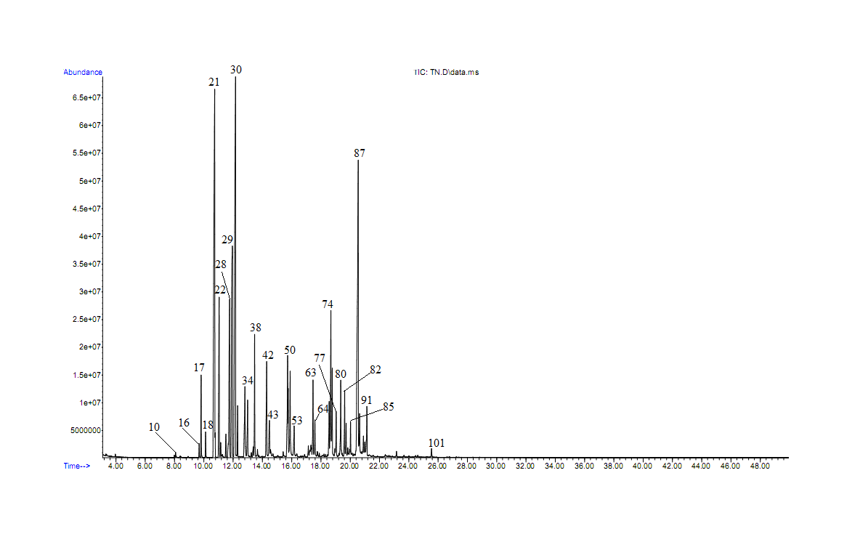
Figure 1: Total ion chromatogram of essential oils of T. nobilis

Table 4: Major chemical constituent of Z. gilletii essential oils
GC-Peak | RI | Compound identified | Chemical Formula | % area | Area
9 | 9.8261 | α-Pinene | C₁₀H₁₆ | 26.20 | 4.27E + 08
10 | 10.1186 | Camphene | C₁₀H₁₆ | 5.68 | 92538630
11 | 10.6685 | Sabinene | C₁₀H₁₆ | 27.98 | 4.56E + 08
12 | 10.7153 | β-Pinene | C₁₀H₁₆ | 6.20 | 1.01 + 08
13 | 11.0195 | β-Myrecene | C₁₀H₁₆ | 6.56 | 1.07 + 08
17 | 11.6513 | o-Cymene | C₁₀H₁₄ | 6.99 | 1.14E + 08
18 | 11.7332 | β-Phellandrene | C₁₀H₁₆ | 9.75 | 1.59E + 08
20 | 12.0842 | E- β-Ocimene | C₁₀H₁₆ | 14.48 | 2.36E + 08
21 | 12.2772 | γ-Terpinene | C₁₀H₁₆ | 3.76 | 61349882
24 | 12.9851 | Linalool | C₁₀H₁₈O | 9.20 | 1.5E + 08
30 | 14.2779 | (R)-4-Methyl-1-(1-methylethyl)-3-cyclohexen-1-ol | C₁₂H₂₀O₂ | 21.54 | 3.51E + 08
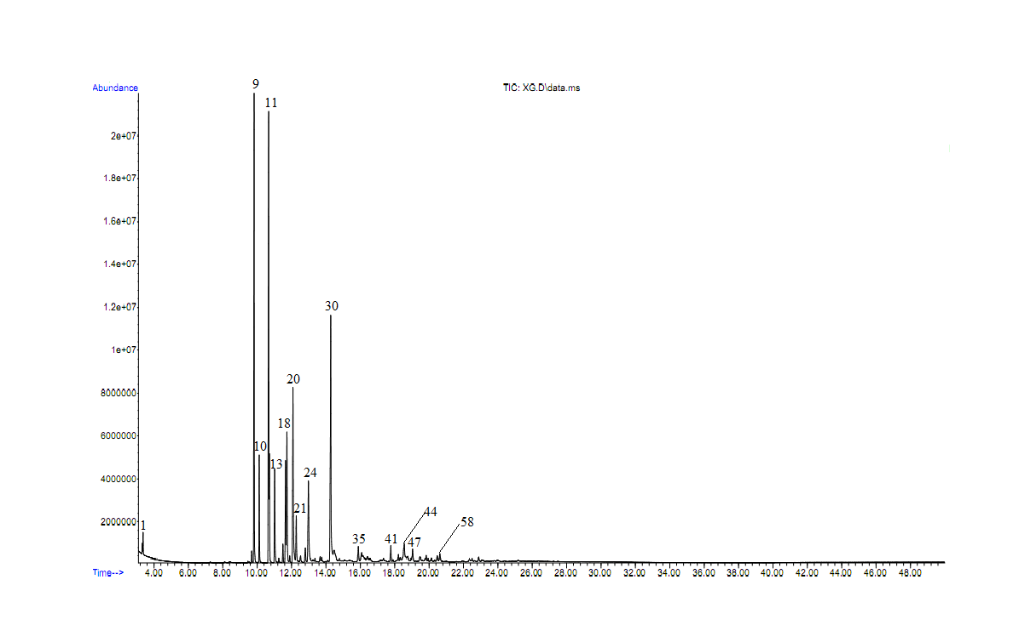
Figure 2: Total ion chromatogram of essential oils of Z. gilletii

