**Supplementary file-Jofhscs 221**

**Paper Title:** Moderating Role of Government Policy on the Relationship Between Economic Stimulus Programs and Education Development: Empirical Evidence from Kenya

**Table 1:** Reliability statistics

|  |  |  |
| --- | --- | --- |
| **Variable** | **Cronbach's Alpha** | **No. of Items** |
| Economic Stimulus Programs | .737 | 5 |
| Government Policy | .735 | 8 |
| Education Development | .743 | 4 |

**Table 2:** KMO and Bartlett's Test

|  |  |  |
| --- | --- | --- |
| ***KMO and Bartlett's Test*** | | |
| Kaiser-Meyer-Olkin Measure of Sampling Adequacy. | | .599 |
| Bartlett's Test of Sphericity | Approx. Chi-Square | 2538.699 |
| df | 136 |
| Sig. | .000 |

**Table 3:** Principal Component analysis results

|  |  |  |  |  |  |  |  |  |  |  |  |  |  |  |  |  |  |  |  |
| --- | --- | --- | --- | --- | --- | --- | --- | --- | --- | --- | --- | --- | --- | --- | --- | --- | --- | --- | --- |
| *Total Variance Explained* | | | | | | | | | | | | | | | | | | | |
| Component | | **Initial Eigenvalues** | | | | | | **Extraction Sums of Squared Loadings** | | | | | | **Rotation Sums of Squared Loadings** | | | | | |
| **Total** | | **% of Variance** | | **Cumulative %** | | **Total** | | **% of Variance** | | **Cumulative %** | | **Total** | | **% of Variance** | | **Cumulative %** | |
| 1 | 3.301 | | 19.417 | | 19.417 | | 3.301 | | 19.417 | | 19.417 | | 2.754 | | 16.203 | | 16.203 | |
| 2 | 2.518 | | 14.810 | | 34.228 | | 2.518 | | 14.810 | | 34.228 | | 2.305 | | 13.558 | | 29.761 | |
| 3 | 2.151 | | 12.652 | | 46.880 | | 2.151 | | 12.652 | | 46.880 | | 1.950 | | 11.468 | | 41.229 | |
| 4 | 1.711 | | 10.062 | | 56.942 | | 1.711 | | 10.062 | | 56.942 | | 1.867 | | 10.983 | | 52.211 | |
| 5 | 1.232 | | 7.245 | | 64.186 | | 1.232 | | 7.245 | | 64.186 | | 1.735 | | 10.208 | | 62.420 | |
| 6 | 1.111 | | 6.536 | | 70.722 | | 1.111 | | 6.536 | | 70.722 | | 1.411 | | 8.302 | | 70.722 | |
| *Extraction Method: Principal Component Analysis.* | | | | | | | | | | | | | | | | | | | |

**Table 4:** *Rotated Component Matrixa*

|  |  |  |  |  |  |  |
| --- | --- | --- | --- | --- | --- | --- |
|  | **Component** | | | | | |
| **1** | **2** | **3** | **4** | **5** | **6** |
| G4 | .715 |  |  |  |  |  |
| G6 | .706 |  |  |  |  |  |
| GI | .650 |  |  |  |  |  |
| G3 | .527 |  |  |  |  |  |
| ESP4 |  | .721 |  |  |  |  |
| ESP5 |  | .719 |  |  |  |  |
| ESP2 |  | .652 |  |  |  |  |
| ESP1 |  | .649 |  |  |  |  |
| ESP3 |  | .617 |  |  |  |  |
| ED2 |  |  | .869 |  |  |  |
| G8 |  |  | .800 |  |  |  |
| ED3 |  |  |  | .788 |  |  |
| G7 |  |  |  | .645 |  |  |
| ED1 |  |  |  |  | .885 |  |
| G5 |  |  |  |  | .814 |  |
| ED4 |  |  |  |  |  | .800 |
| G2 |  |  |  |  |  | .749 |
| *Extraction Method: Principal Component Analysis.*  *Rotation Method: Varimax with Kaiser Normalization.* | | | | | | |
| *a. Rotation converged in 23 iterations.* | | | | | | |

**Table 5:** Respondents’ demographic characteristics

|  |  |  |  |  |  |  |  |  |  |  |  |
| --- | --- | --- | --- | --- | --- | --- | --- | --- | --- | --- | --- |
|  | | | | **Frequency** | | | | **Percent** | | | |
| Gender | Male | | 148 | | | | 40.0 | | | |
| Female | | 222 | | | | 60.0 | | | |
| **Total** | | **370** | | | | **100.0** | | | |
| Age | 18-30 Years | | | | 148 | | | | 40.0 | |
| 31-45 | | | | 111 | | | | 30.0 | |
| 46-60 | | | | 111 | | | | 30.0 | |
| **Total** | | | | **370** | | | | **100.0** | |
| Education | No formal education | | | | 74 | | | | 20.0 | |
| Primary School | | | | 111 | | | | 30.0 | |
| High School | | | | 37 | | | | 10.0 | |
| College | | | | 74 | | | | 20.0 | |
| University | | | | 74 | | | | 20.0 | |
| **Total** | | | | **370** | | | | **100.0** | |
| Residency | 0-5 years | 74 | | | | 20.0 | | | |
| 6-10 years | 37 | | | | 10.0 | | | |
| 11-15 years | 111 | | | | 30.0 | | | |
| Over 16 years | 148 | | | | 40.0 | | | |
| **Total** | **370** | | | | **100.0** | | | |

**Table 6:** Descriptive statistic and correlation analysis

|  |  |  |  |  |  |
| --- | --- | --- | --- | --- | --- |
|  | **Mean** | **SD** | **ED** | **G** | **ESP** |
| **ED** | 3.87 | 1.31 | 1 |  |  |
| **G** | 3.84 | 1.29 | .817** | 1 |  |
| **ESP** | 3.98 | 1.24 | .533** | .613** | 1 |

*\*\*. Correlation is significant at the 0.01 level (2-tailed).*

**Table 7:** Test for direct effects on dependent variable

|  |  |  |  |  |  |  |  |  |
| --- | --- | --- | --- | --- | --- | --- | --- | --- |
| **Model** | | **Unstandardized Coefficients** | | | **Standardized Coefficients** | **t** | **Sig.** | |
| **B** | | **Std. Error** | **Beta** |
| 1 | (Constant) | .139 | | .016 |  | 8.727 | .000 | |
| EPS | .561 | | .046 | .533 | 12.070 | .000 | |
| **Model Summary** | | | | | | | | | |
| R | | | .533 | | | | |
| R2 | | | .284 | | | | |
| R2 Change | | | .284 | | | | |
| Std. Error of the Estimate | | | .09892 | | | | |
| **Model Fit** | | | | | | | | | |
| F | | | 145.681 | | | | |
| F change | | | 145.681 | | | | |
| Sig. | | | .000 | | | | | | |

**Table 8:** Test for moderator on dependent variable

|  |  |  |  |  |  |  |  |  |
| --- | --- | --- | --- | --- | --- | --- | --- | --- |
| **Model** | | **Unstandardized Coefficients** | | | **Standardized Coefficients** | **t** | **Sig.** | |
| **B** | | **Std. Error** | **Beta** |
| 2 | (Constant) | .031 | | .012 |  | 2.600 | .010 | |
| EPS | .054 | | .040 | .051 | 1.342 | .180 | |
| GP | .892 | | .043 | .786 | 20.714 | .000 | |
| **Model Summary** | | | | | | | | | |
| R | | | .818 | | | | |
| R2 | | | .670 | | | | |
| R2 Change | | | .386 | | | | |
| Std. Error of the Estimate | | | .06726 | | | | |
| **Model Fit** | | | | | | | | | |
| F | | | 372.096 | | | | |
| F change | | | 429.056 | | | | |
| Sig. | | | .000 | | | | | | |

|  |  |  |  |
| --- | --- | --- | --- |
|  | **Model 1**  **β(*p*)** | **Model 2**  **β(*p*)** | **Model 3**  **β(*p*)** |
| (Constant) | .139  (0.000) | .031  (0.010) | 1.394  (0.000) |
| **Main Effect** |  |  |  |
| Economic Stimulus Program | .561  (0.000*) | .054  (0.180) | -.032  (0.000*) |
| **Moderator** |  |  |  |
| Government Policy |  | .892  (0.000*) | -.866  (0.000*) |
| **Interaction term** |  |  |  |
| X1 |  |  | -0.052  (0.000*) |
| **Model Summary** |  |  |  |
| R | 0.533 | 0.818 | 0.992 |
| R Square | 0.284 | 0.670 | 0.984 |
| Std. Error of the Estimate | 0.09892 | 0.06726 | 0.01498 |
| R Square Change | 0.284 | 0.386 | 0.314 |
| **Model Fit** |  |  |  |
| F Change | 145.681 | 429.056 | 7036.467 |
| Sig. F Change | 0.000 | 0.000 | 0.000 |

**Table 9:** Interaction effect of government policy on economic stimulus programs and education development

**\***Significant at *p* < 0.05

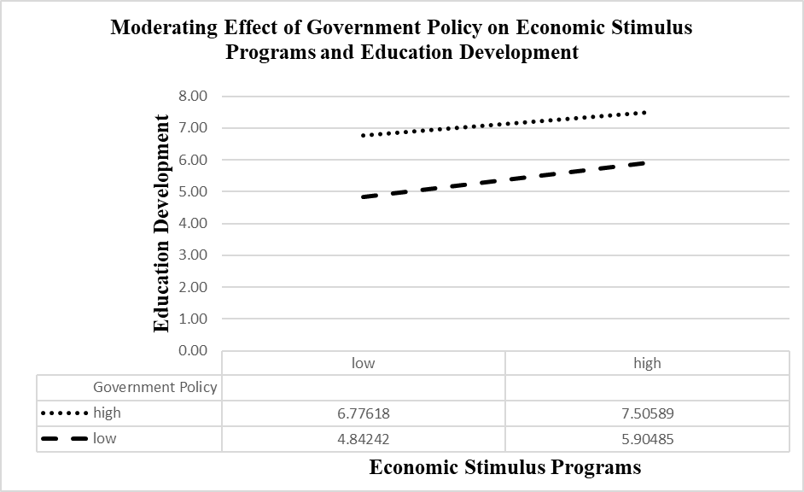

**Figure 1:** Mod Graphs of the impact that government policy has on the relationship between economic stimulus programs and education development