**Supplementary file -Jobmers 225**

**Article Title:** Does Size Matter? Portfolio Diversification and Financial Performance of Commercial Banks in Kenya: Testing the Moderating Effect of Bank Size

**Model 1**. Testing the effect of control variables on the financial performance.

$$FP= β_{0}+β_{1}{CA}_{it}+β_{2}{AQ}_{it}+β_{3}L_{it} +ε_{it}$$

**Model 2**. Testing the effect of independent variable on financial performance.

$$FP= β_{0}+β_{1}C_{it}+β_{2}{IPD}_{it}+ε_{it}$$

**Model 3**. Testing the moderating effect of bank size on financial performance.

$$FP= β_{0}+β_{1}C_{it}+β_{5}{IPD}_{it}+β_{6}{BS}_{it}+ε_{it}$$

**Model 4.** Introducing the first interaction term between sectorial investment portfolio diversification and bank size.

$$FP= β_{0}+β_{1}C_{it}+β_{2}{IPD}_{it}+β_{6}{BS}_{it}+β_{7}{IPD}_{it}*BS+ε_{it}$$

Table 1: Descriptive statistics

|  |  |  |  |  |  |  |
| --- | --- | --- | --- | --- | --- | --- |
| **Variable** | **Mean** | **Std. Dev.** | **Min** | **Max** | **Obs.** | |
| Financial Performance (ROA) | 3.872 | 3.738 | -12.31 | 12.08 | | 190 |
| Investments Portfolio diversification | 0.151 | 0.118 | 0.062 | 0.217 | | 190 |
| Bank Size | 11.16 | 10.17 | 10.36 | 12.05 | | 190 |
| Liquidity | 0.211 | 0.108 | 0.144 | 0.391 | | 190 |
| Asset quality | 0.124 | 0.091 | 0.093 | 0.187 | | 190 |
| Capital adequacy | 18.48 | 8.912 | 11.761 | 39.15 | | 190 |

*Source: Field Data, 2023*

Table 2: Correlation analysis of study variables

|  |  |  |  |  |  |  |  |  |  |
| --- | --- | --- | --- | --- | --- | --- | --- | --- | --- |
|  | **SCD** | **Banc** | **DPD** | **IPD** | **Liq** | **AQ** | **CA** | **BS** | **ROA** |
| IPD | -.291** | .045 | .020 | 1 |  |  |  |  |  |
| Liq | -.230** | .232** | .050 | .196** | 1 |  |  |  |  |
| AQ | .151* | -.129 | -.213** | -.063 | -.250** | 1 |  |  |  |
| CA | -.426** | .044 | .075 | .338** | .182* | -.147* | 1 |  |  |
| BS | -.348** | .142* | -.025 | .242** | .215** | -.150* | .270** | 1 |  |
| ROA | -.421** | .080 | -.348** | .456** | .170* | -.103 | .355** | .279** | 1 |
| **. Correlation is significant at the 0.01 level (2-tailed). | | | | | | | | | |
| *. Correlation is significant at the 0.05 level (2-tailed).  *Source: Field Data, 2023* | | | | | | | | | |

Table 3: Effect of the control variables on financial performance

Fixed-effects (within) regression Number of obs = 190

Group variable: Bank Number of groups = 38

R-sq: Obs per group:

within = 0.6378 min = 5

between = 0.4165 avg = 5.0

overall = 0.4674 max = 5

F(3,149) = 87.47

corr(u_i, Xb) = -0.5408 Prob > F = 0.0000

|  |  |  |  |  |  |  |  |
| --- | --- | --- | --- | --- | --- | --- | --- |
| **ROA** | **Coef.** | **St.Err.** | **t-value** | **p-value** | **[95% Conf** | | **Interval]** |
| LIQ | -.091 | .084 | -1.08 | .281 | -.258 | | .076 |
| AQ | -.019 | .039 | -0.48 | .63 | -.095 | | .058 |
| CA | 1.045 | .065 | 16.05 | 0.000 | .916 | | 1.173 |
| Constant | 0.000 | .034 | -0.00 | 1 | -.067 | | .067 |
| sigma_u | 0.72384591  sigma_e | 0.46401466  rho | 0.70875081 | | (fraction of variance due to u_i) | | | |  | |
| Mean dependent var | | 0.000 | SD dependent var | | | 1.000 | |
| R-squared | | 0.638 | Number of obs | | | 190 | |
| F-test | | 87.474 | Prob > F | | | 0.000 | |
| F test that all u_i=0: F(37, 149) = 7.51 Prob > F = 0.0000 | | | | | | | |
| **Note:** *sigma_u is the standard deviation of residuals within groups, sigma_e is the standard deviation of residuals (overall error terms), rho is the intraclass correlation*. | | | | | | | |

Table 4: Results for fixed effect model on direct effect

Fixed-effects (within) regression Number of obs = 190

Group variable: Bank Number of groups = 38

R-sq: Obs per group:

within = 0.6942 min = 5

between = 0.3963 avg = 5.0

overall = 0.5239 max = 5

F(7,145) = 47.02

corr(u_i, Xb) = -0.2028 Prob > F = 0.0000

|  |  |  |  |  |  |  |  |  |
| --- | --- | --- | --- | --- | --- | --- | --- | --- |
| **ROA** | **Coef.** | | **St.Err.** | **t-value** | **p-value** | **[95% Conf** | | **Interval]** |
| LIQ | -.057 | | .079 | -0.72 | .471 | -.214 | | .099 |
| AQ | -.022 | | .037 | -0.59 | .553 | -.096 | | .052 |
| CA | .687 | | .097 | 7.11 | 0.000 | .496 | | .878 |
| IPD | .153 | | .043 | 3.60 | 0.000 | .069 | | .237 |
| Constant | 2.64 | | .031 | 0.00 | 1 | -.062 | | .062 |
| sigma_u | 0.59544825  sigma_e | 0.43224548  rho | 0.65489849 (fraction of variance due to u_i) | | | | | | | | |
| Mean dependent var | | 0.000 | | SD dependent var | | | 1.000 | |
| R-squared | | 0.694 | | Number of obs | | | 190 | |
| F-test | | 47.017 | | Prob > F | | | 0.000 | |

F test that all u_i=0: F(37, 145) = 7.80 Prob > F = 0.0000

**Note:** *sigma_u is the standard deviation of residuals within groups, sigma_e is the standard deviation of residuals (overall error terms), rho is the intraclass correlation*.

Table 5: Moderating effect of bank size

Fixed-effects (within) regression Number of obs = 190

Group variable: Bank Number of groups = 38

R-sq: Obs per group:

within = 0.7155 min = 5

between = 0.3729 avg = 5.0

overall = 0.5000 max = 5

F(8,144) = 45.27

corr(u_i, Xb) = -0.3616 Prob > F = 0.0000

|  |  |  |  |  |  |  |  |  |
| --- | --- | --- | --- | --- | --- | --- | --- | --- |
| **ROA** | **Coef.** | | **St.Err.** | **t-value** | **p-value** | **[95% Conf** | | **Interval]** |
| LIQ | -.045 | | .077 | -0.59 | 0.556 | -.197 | | .106 |
| AQ | -.029 | | .036 | -0.81 | 0.421 | -.101 | | .042 |
| CA | .704 | | .094 | 7.51 | 0.000 | .519 | | .889 |
| IPD | .132 | | .042 | 3.16 | 0.002 | .05 | | .215 |
| BS | .414 | | .126 | 3.29 | 0.001 | .165 | | .664 |
| Constant | -8.36 | | .03 | -0.00 | 1 | -.06 | | .06 |
| sigma_u | 0.65646317  sigma_e | 0.41835025  rho | 0.71117451 (fraction of variance due to u_i) | | | | | | | | |
| Mean dependent var | | 0.000 | | SD dependent var | | | 1.000 | |
| R-squared | | 0.715 | | Number of obs | | | 190 | |
| F-test | | 45.268 | | Prob > F | | | 0.000 | |
| F test that all u_i=0: F(37, 144) = 8.21 Prob > F = 0.0000 | | | | | | | | |
| **Note:** *sigma_u is the standard deviation of residuals within groups, sigma_e is the standard deviation of residuals (overall error terms), rho is the intraclass correlation* | | | | | | | | |

Table 6: Testing the complete effect of moderation

Fixed-effects (within) regression Number of obs = 190

Group variable: Bank Number of groups = 38

R-sq: Obs per group:

within = 0.7213 min = 5

between = 0.3619 avg = 5.0

overall = 0.4964 max = 5

F(12,140) = 30.20

corr(u_i, Xb) = -0.3570 Prob > F = 0.0000

|  |  |  |  |  |  |  |  |  |
| --- | --- | --- | --- | --- | --- | --- | --- | --- |
| **ZROA** | **Coef.** | | **St.Err.** | **t-value** | **p-value** | **[95% Conf** | | **Interval]** |
| LIQ | -.052 | | .078 | -0.67 | .503 | -.205 | | .101 |
| AQ | -.059 | | .047 | -1.26 | .209 | -.152 | | .033 |
| CA | .682 | | .1 | 6.81 | .000 | .484 | | .88 |
| IPD | 0.13 | | .042 | 3.09 | .002 | .047 | | .213 |
| BS | .434 | | .131 | 3.31 | .001 | .174 | | .694 |
| IPD*BS | -.002 | | .073 | -0.02 | .981 | -.147 | | .143 |
| Constant | 0.000 | | .032 | 0.00 | .998 | -.064 | | .064 |
| sigma_u | .66087416  sigma_e | .41992625  rho | .71237947 (fraction of variance due to u_i) | | | | | | | | |
| Mean dependent var | | 0.000 | | SD dependent var | | | 1.000 | |
| R-squared | | 0.721 | | Number of obs | | | 190 | |
| F-test | | 30.196 | | Prob > F | | | 0.000 | |
| F test that all u_i=0: F(37, 140) = 7.90 | | | | | | | | |
| **Note:** *sigma_u is the standard deviation of residuals within groups, sigma_e is the standard deviation of residuals (overall error terms), rho is the intraclass correlation* | | | | | | | | |

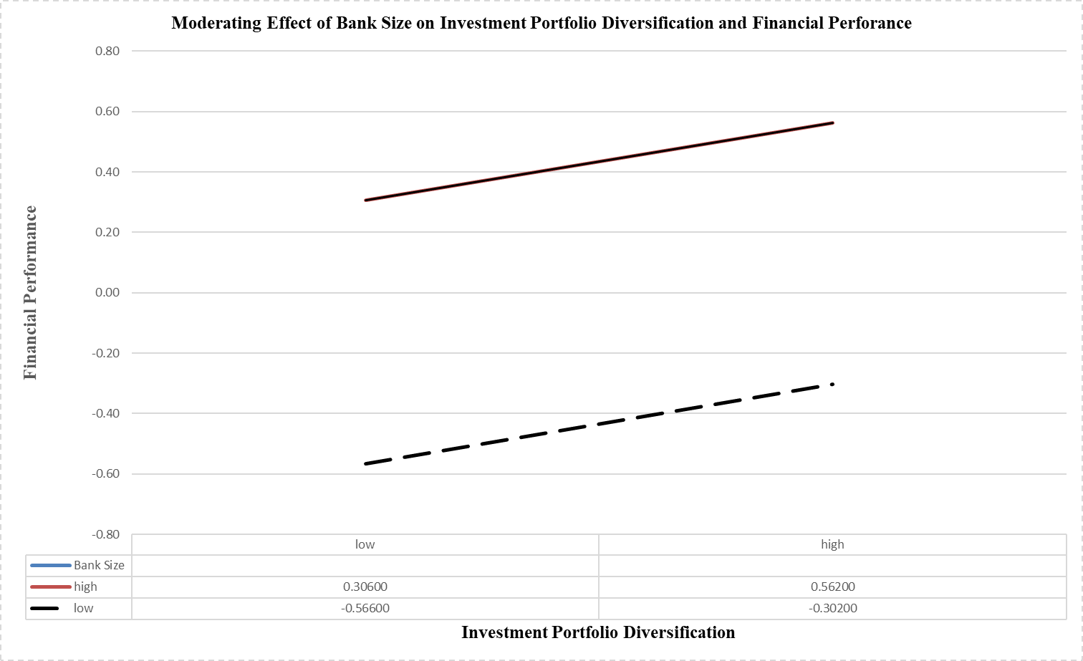

**Figure 1:** Moderating Effect of Bank Size on Investment Portfolio Diversification and Financial Performance